Veenendaal Location and Hotel Information
Elekta
E&T Centre room K008
Waardgelder 1
3905 T.H. Veenendaal
Please make sure you bring a valid ID when you come to the office.
Hotel
Especially for our Elekta colleagues and guests we have made arrangements with the Hotel Veenendaal, a van der Valk Hotel, in Veenendaal. For reservations please use the Hotel Veenendaal reservation form that has been sent with this email. Please check the checkbox when you would like a transfer between the hotel and our office.
‘Hotel Veenendaal
Bastion 73
3905 NJ Veenendaal
+31 (0)318 799 060
info@veenendaal.valk.com

The corporate rate is: Room including breakfast: EUR 81,50 (incl. VAT)
Taxi from Hotel Veenendaal to Elekta: EUR 12,- ( 1-3 persons) and EUR 18,- (4-8 persons)
Taxi from Hotel Veenendaal / Elekta office to Amsterdam Schiphol Airport : 1-3 persons EUR 110,- /4-8 EUR 135,-
Bicycle rent: €8,50 per day (only on reservation, availability is limited)

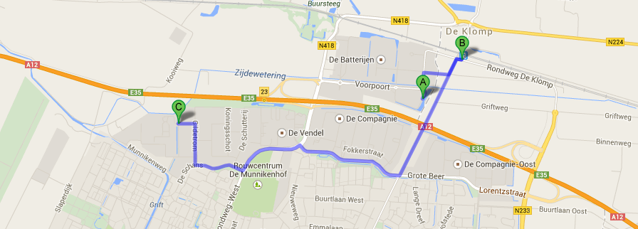
A=Hotel Veenendaal B=Trainstation Veenendaal-De Klomp C=Elekta
Directions
When you come in by plane you can take the train to station Veenendaal-De Klomp.
It will take about 1 Hrs. and 10 Minutes to reach the station and the costs are about €15,00.
You will have to switch trains 1 time at Utrecht Central
From station Veenendaal-De Klomp you can reach the hotel by foot (5-10 min) or you need to take a taxi.
Please call Taxi van Ojik:+31-318500600
Schiphol station is situated directly below the airport. You can pick up a free baggage trolley from the platform. Via Schiphol Plaza, you can walk straight to the departure or arrival hall. Train tickets for domestic travel are available from the yellow ticket machines near the platforms at Schiphol Plaza. Tickets (for domestic and international travel) are also available from the ticket offices, which are situated close to the red/white-checked cube at Schiphol Plaza. Staff at the ticket offices will also be able to provide you with train departure information
It is also possible to take a taxi from the airport to the hotel.
When you want to arrange your taxi up front, please use attached Aiportservice reservation form and send it directly to the email address mentioned on the form.
Total expenses for the ride are approximately €110,-(1-3 persons) or €135 (4-8 persons)
When you arrive at our Elekta office please report at the reception desk. Your host will be notified and will come to pick you up and accompanies you to the Education & Training Centre.

